Lumberjack Journal
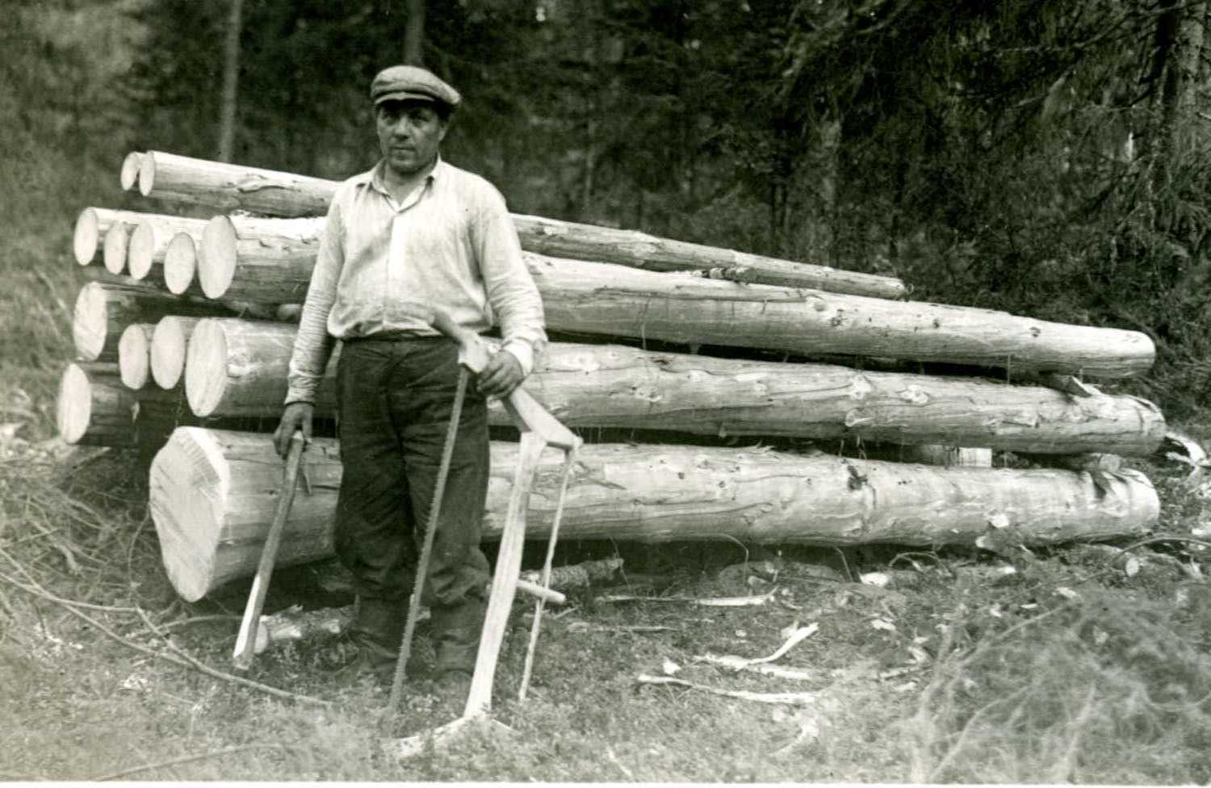

Sentence starters…

Class was really interesting because…
Today, I learned…
I am not sure about…
I would like to learn more about…
I made a connection to…
Today at lumberjack camp, I...

Format You Should always enter in your journal:
Date __ / __ / __
Journal Topic: __________________________

____________________________________________________________________________________________________________________________________________________________

